Department of Engineering, Computer Programming, and Technology
Division of Computer Programming and Analysis
Valencia College Osceola Campus
COP 1000C-S06
Introduction to Computer Programming
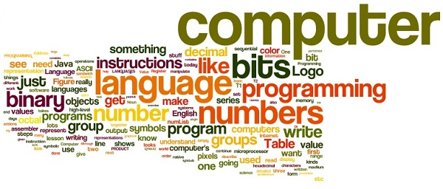
Course Syllabus

Professor: Andrew Eisler
Contact Number: (321) 427-0938 text/cell
Course Title: Introduction To Programming Concepts
Course Number: COP 1000C-S06
Course CRN: 16250
Course Description: this course provides the beginning programmer with a solid foundation in programming theory and practice. The course assumes no programming experience. Good programming style and logical thinking are emphasized throughout the semester.
Specific teaching coverage includes:
- An Introduction to Programming
- Beginning the Problem-Solving Process
- Variables and Constants Completing the Problem-Solving Process
- The Selection Structure More on the Selection Structure
- The Repetition Structure More on the Repetition Structure
- Value-Returning Functions Void Functions
- One-dimensional Arrays Two-dimensional Arrays
- Strings Sequential Access Files
- Classes and Objects
---------------------------------------------------
Program Information: Program Outcomes, Sequence,
Prerequisites, Post-requisites
This course is designed as a beginning programming course.
Course Outcomes
Plan and create well-structured programs
Learn how to write programs using the sequence, selection, and repetition structures
Create and manipulate functions, sequential access files, arrays, strings, classes and objects
Required Texts and Resources
Diane Zak, An Introduction to Programming with C++, Eighth Edition. Course Technology, Cengage Learning, 2016, ISBN 9781285860114.
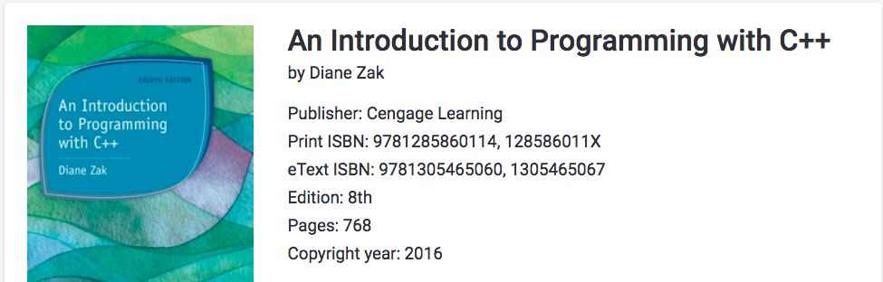
------------------------------------------------
Graded Assignments
Assessment Type | Weight as a Percentage
Final examination  This examination is cumulative and is given in a variety of formats. An in-class review will be held prior to the final examination. | 20%
Midterm exams (2)  The examination is given in a variety of formats. The date of the exam is shown on the Course Outline. An online class review will be held prior to each examination. | 40%
Providing solutions to Exercises at the end of each chapter  Required Exercises are listed in the Course Outline. | 30%
Online quizzes  Quizzes are announced one day in advance and may vary from 5-10 questions that may be in any format. | 10%
Total Points | 100

Course Outline
The following table outlines the course schedule.
Week | Chapter  Readings | Labs | Assignments/  Homework | Exams
1 | Ch 1 | Exercises: Computer | Review Questions; Exercises: Pencil and Paper
2 | Ch 2 | Exercises: Computer | Review Questions; Exercises: Pencil and Paper
3 | Ch 3 | Exercises: Computer | Review Questions; Exercises: Pencil and Paper
4 | Ch 4 | Exercises: Computer | Review Questions; Exercises: Pencil and Paper
5 | Ch 5 | Exercises: Computer | Review Questions; Exercises: Pencil and Paper | EXAM 1
6 | Ch 6 | Exercises: Computer | Review Questions; Exercises: Pencil and Paper
7 | Ch 7 | Exercises: Computer | Review Questions; Exercises: Pencil and Paper
8 | Ch 8 | Exercises: Computer | Review Questions; Exercises: Pencil and Paper
9 | Ch 9 | Exercises: Computer | Review Questions; Exercises: Pencil and Paper
10 | Ch 10 | Exercises: Computer | Review Questions; Exercises: Pencil and Paper | EXAM 2
11 | Ch 11 | Exercises: Computer | Review Questions; Exercises: Pencil and Paper
12 | Ch 12 | Exercises: Computer | Review Questions; Exercises: Pencil and Paper
13 | Ch 13 | Exercises: Computer | Review Questions; Exercises: Pencil and Paper
14 | Ch 14 | Exercises: Computer | Review Questions; Exercises: Pencil and Paper
15 | Ch 15 | Exercises: Computer | Review Questions; Exercises: Pencil and Paper | EXAM 3
Learning Support Services
Provides students with academic support through tutoring, library services and resources. Tutoring is offered in most academic disciplines including math, science and coursework specific to each campus. Online tutoring is offered through Smarthinking and can be accessed through Atlas. Assistance with library research can be accessed in person or online through Atlas. Students also have access to resources such as calculators, laptops, iPads, group study rooms and quiet study rooms within the Learning Support areas. For campus specific information, please visit the college-wide Learning Support Services website at http://valenciacollege.edu/learning-support/.
DISCLAIMER
Changes to this syllabus may be made at any time by announcement of the professor in class or as an Announcement in Canvas.
---------------------------------------
Andrew Eisler, B.A., M.S., Ed.S.
Intellectual Content © Copyright 2018.
All other content © Copyright 2018,
Valencia College (Links to an external site.)Links to an external site.
For Technical Support, contact the Valencia OIT Help Desk
1-407-785-5555

