Course Syllabus

ACG 3024 Accounting and Financial Analysis for Managers

Valencia College

Course Overview
Understanding Finance and Accounting will equip managers with the knowledge necessary to communicate more effectively with financial managers, analyze financial statements and understand how they relate, interpret a company's profitability, solvency and liquidity, explore the sources and costs of capital and the factors of investment decisions, and learn valuation principles and their impact on the value drivers of the firm. Students will gain both competence and confidence in their interactions with financial colleagues and senior executives.

Course Information
CRN: 202420-ACG 3024-23882- Accounting and Financial Analysis for Managers
Term: Spring 2024
Modality: Online
Credit Hours: 3

Catalog Description
This course addresses the use of accounting and finance information in a managerial setting to support decision making. Students will learn how to classify and analyze financial data included on various Financial Statements and analyze ethical and/or social responsibility issues that may arise from such statements. An emphasis will be placed on utilizing a variety of analysis tools, including time value of money concepts and cost-volume-profit tools, to develop and analyze strategic, operational, and capital budgets.

Course Major Learning Outcomes
- Students will analyze ethical dilemmas and social responsibility issues in organizations.
- Students will classify elements of Financial Statements: Income Statement, Statement of Owner's Equity, Balance Sheet, and Statement of Cash Flows.
- Students will use financial ratios to analyze financial statements.
- Students will develop operational and strategic budgets to inform managerial decision making.
- Students will analyze operational and strategic budget performance.
- Students will apply the time value of money through the use of present and future value scenarios.
- Students will use cost-volume-profit analysis tools for managerial decision making.

Prerequisites
Admission to the B.A.S degree in Business and Organizational Leadership, and a minimum grade of C in one of the following courses or by departmental approval:
- MAC 1105 College Algebra
- APA 1111C Applied Accounting
- ACG 2021C Principles of Financial Accounting
- FIN 2000 Principles of Finance
- MGF 1106 Liberal Arts Mathematics
- MGF 1107 Liberal Arts Mathematics II
- MTB 1103 Business Mathematics

Faculty Information
Faculty Name: Christina Partridge, CPA
Faculty Email: cpartridge@valenciacollege.edu
Office Phone: Contact instructor by email if needed
Office Location: Online
Office Hours: Contact instructor

Required Text
This course uses open educational resources (OERs) and other materials for educational usage. Therefore, students are not required to purchase any textbooks for this course. The required resources for this course are listed within the course and can be readily accessed using the provided links or attachments. There may be additional required and/or recommended readings, supplemental materials, or other resources and websites necessary which will be provided within the course, and throughout the term via the assignment/discussion/quiz or exam areas.

Grading Policy

Grading Breakdown
Your grade in this course will be calculated based on the following assignment categories:
Discussions................................... 20%
Mini-quizzes................................. 25%
Quizzes.......................................... 25%
Exams and Final Exam..................30%
100%

Grading Scale
Your letter grade will be based on the following grading scale:
Grading Scale
Total Percentage | Letter Grade
90% - 100% | A
80% - 89.9% | B
70% - 79.9% | C
60% - 69.9% | D
0% - 59.9% | F

Course Policies

Assignments and Grading Information
Schedule and Deadlines. You may view the assignment schedule, along with assignment deadlines, on our course schedule and webpage through Canvas. We will learn how to navigate this site as a class within our first few class meetings. You can familiarize yourself with Canvas.
Discussion Instructions (Initial Post is Require before “Viewing” Peer Posts) - 10 points each: You are required to submit a substantial response. A substantial response is one that stays on topic and fully addresses the assignment in a clear, concise, and meaningful manner. Substantial Content refers to providing relevant content toward the actual topic of the discussions. This includes quality input, questions and information in your discussion posts and responses to peers.
The deliverable length of initial posting must be at least 150 words. After the initial posting, students are required to respond to at least two (2) peers responses. Peer responses must be at least 50 words for each response, in order to receive full credit. Discussions must be the students original thoughts based on the topics from the "Open Educational Resource" (OER) Course Textbook and/or other referenced sources. Direct quotes from references must be less than 10 words. Please review postings for sentence structure, grammar and punctuation errors.
Discussion Posting Rules
- Personal attacks of other students because of their posts will not be tolerated.
- Provide clear analysis and insight into the topic or questions.
- Post original thoughts to avoid plagiarism and the penalties for plagiarism
- Zero or minimal credit will be given to students with very FEW or NO SUBSTANTIVE postings or who post all posts with in a matter of minutes or all on the last day.
- Proof postings to eliminate offensive references, poor sentence syntax, misspelled words, etc.
Mini-quiz Instructions - 5 points each: Mini-quizzes contain randomly selected multiple choice, matching, and/or computational questions. Students will have 2 attempts to complete the mini-quiz (no time limit). Students must complete the entire mini-quiz in the attempt (If the mini-quiz or the web browsers is closed - the mini-quiz is considered completed). The highest score is kept. The mini-quiz consists of randomly selected multiple choice, matching, and/or computational questions based on the related chapter(s) learning objectives of each module covered.
Quiz Instructions - 10 points each: Quizzes contain randomly selected multiple choice, matching, and/or computational questions. Students will have 1 attempt to complete the quiz (no time limit). Students must complete the entire quiz in the attempt (If quiz or the web browsers is closed - the quiz is considered completed). The Quiz consists of randomly selected multiple choice, matching, and/or computational questions based on the related chapter(s) learning objectives of each module covered.
Exam Instructions: Exams (18-20 points each) and the Final Exam (50 points) contain randomly selected multiple choice, matching, and/or computational questions. Students will have 1 attempt to complete the exam (no time limit). Students must complete the entire exam in the attempt (If the exam or the web browsers is closed - the exam is considered completed). The exam consists of randomly selected multiple choice, matching, and/or computational questions based on the related chapter(s) learning objectives of each module covered.

Course Communication Policy
You may contact me through the Canvas Inbox Monday - Friday. I will respond to your message within 48 hours with the exception of days and times when the college is closed.
Students must have an active Atlas account. Students must check their Atlas e-mails regularly as to not miss any important messages from the professor. Missed messages via Atlas or any other medium (in-class, etc.) may affect your grade and are the responsibility of the student.

Academic Integrity Policy
Academic integrity is the pursuit of scholarly activity in an open, honest and responsible manner. Both students and instructors are expected to obey the rules of honest scholarship. Academic misconduct--cheating--is not just "against the rules." It violates the assumptions at the heart of all learning. It destroys the mutual trust and respect that should exist between student and professor. It is unfair to students who earn their grades honestly. Students are expected to model academic integrity by presenting original thoughts, research, and self-expression. Ideas, language, and/or research from other sources must be appropriately acknowledged.
All forms of academic dishonesty are prohibited at Valencia College. Academic dishonesty includes, but is not limited to, acts or attempted acts of plagiarism, cheating, furnishing false information, forgery, alteration or misuse of documents, misconduct during a testing situation, facilitating academic dishonesty, and misuse of identification with intent to defraud or deceive.
In this course, your assignment submissions will be scanned using the Unicheck plagiarism checker. If your assignment submission is determined to be plagiarized work, a first offense will result in a score of zero on the assignment, and a second offense will result a class grade of F.

College Student Conduct Policy
Valencia is dedicated not only to the advancement of knowledge and learning but also to the development of responsible personal and social conduct. As a registered student, you assume the responsibility for conducting yourself in a manner that contributes positively to Valencia’s learning community and that does not impair, interfere with, or obstruct the orderly conduct, processes, and functions of the college as described in the Student Code of Conduct.

Attendance Policy
This is an online course, available 24/7, managed through Canvas. You must have access to the Internet (available on all Valencia campuses) to complete the course requirements. You are expected to log in to the course website on Canvas throughout the week to keep up with readings, assignments, discussions and quizzes.
If you are unable to participate in the course due to illness or family emergency, please communicate with me as soon as possible in order to create a plan for the best course of action. In the case of a prolonged online absence of one week or more, you and I will meet to discuss options and determine your ability to continue in the course.
Remember, technical problems with Canvas or your internet connection will not be an acceptable excuse for late submissions. Do not wait until the last minute to submit assignments.
If you stop attending and/or participating in class and appear on the roster at the end of the course, you will receive a standard letter grade.

Late Work/Makeup Policy
If you foresee an extended absence in this course, consider working ahead to meet deadlines. In unexpected situations, please reach out to your professor as soon as possible. Any extensions beyond the established due date(s) will be considered only if students provide written documentation of a medical emergency or ongoing medical condition. This must be presented within 48 hours of the missed work.
For more information on Valencia College “Attendance Policy” Click Here: Attendance Policy

Withdrawal Policy
You should familiarize yourself with Valencia College’s withdrawal policy (see college catalog). Per Valencia policy, a student who withdraws from class before the established deadline for a particular term will receive a grade of “W. A student is not permitted to withdraw after the withdrawal deadline. Any student who withdraws or is withdrawn from a class during a third or subsequent attempt in the same course will be assigned a grade of “F.” If you do not intend to complete the course, you must withdraw yourself prior to the withdrawal date.
Spring 2024 Withdrawal Deadline is March 15, 2024

Copyright Policy
To avoid copyright infringement, any materials produced specifically for this class can ONLY be used during this term for this class.

Academic Support Services

Academic Accommodations for Students with Disabilities
Valencia is committed to ensuring that all of its programs and services are accessible to students with disabilities. The Office for Students with Disabilities (OSD) determines reasonable and appropriate accommodations for qualified students with documented disabilities based upon the need and impact of the specific disability. Any student requiring course accommodations due to physical, emotional or learning disability must contact the instructor and provide a Notification to Instructor form by the end of the second week of class. To obtain a letter of accommodation, contact OSD at 407-582-2229.

BayCare Student Assistance Program
Valencia College strives to ensure all our students have a rewarding and successful college experience. To that purpose, Valencia students can get immediate help with issues dealing with stress, anxiety, depression, adjustment difficulties, substance abuse, time management as well as relationship problems dealing with school, home or work. BayCare Behavioral Health Student Assistance Program (SAP) services are free to all Valencia students and available 24 hours a day by calling (800) 878-5470. If needed, the counselor may refer the student to appropriate resources or to speak face-to-face with a licensed counselor.

Learning Support
Each Valencia campus has a Learning Center that provides resources such as online tutoring, writing consultations, and skillshops to students. To locate available resources for the campus closest to you, view the Learning Support website.

Microsoft
As a Valencia student, you have access to Microsoft Word (as well as Microsoft Excel, Powerpoint, etc) free for personal use. You can learn more about accessing these applications in Atlas, on the "My Atlas" tab, right hand column, under "Microsoft Office for Personal Use."

Brainfuse
As a Valencia student you have access to free, on-demand instruction and support from expert tutors across a wide variety of subjects with Brainfuse's online tutoring. Watch a short overview of Brainfuse’s services on their YouTube channel and/or review the Brainfuse User Guide.

Technical Support
To get assistance with Canvas issues, select the "Help" link in the global navigation menu, lower left corner of the screen. The "Help" link offers different ways to get help with Canvas, including:

  - Ask your Instructor a Question, which allows users to send a detailed message to their instructor.
  - Obtain technical assistance by clicking on Chat with Canvas Support (available 24/7).
  - Call the Canvas Support Hotline at 407-582-5600 (available 24/7).
  - Click on Create a Support Ticket, and type in a detailed description of the problem. This ticket will be directed to the appropriate support channel.
  - Explore the Canvas Student Guide for tutorials covering common technical issues.

Institutional Core Competencies
The following Valencia Student Competencies will be reinforced throughout the entire course:
- THINK – Analyze data, ideas, patterns, principles, and perspectives employing facts, formulas and procedures of the discipline.
- VALUE – Distinguish among personal, ethical, aesthetic, cultural, and scientific values evaluating your own and others values from a global perspective in the process of learning the discipline.
- COMMUNICATE – Identify your own strengths and need for improvement as a communicator employing methods of communication appropriate to your audience and purposefully evaluate the effectiveness of your own and others communication.
- ACT – Apply disciplinary knowledge, skills, and values to educational and career goals acting effectively and appropriately in various personal and professional settings responding also to changing circumstances.

Course Schedule - Please see the Course Summary below.

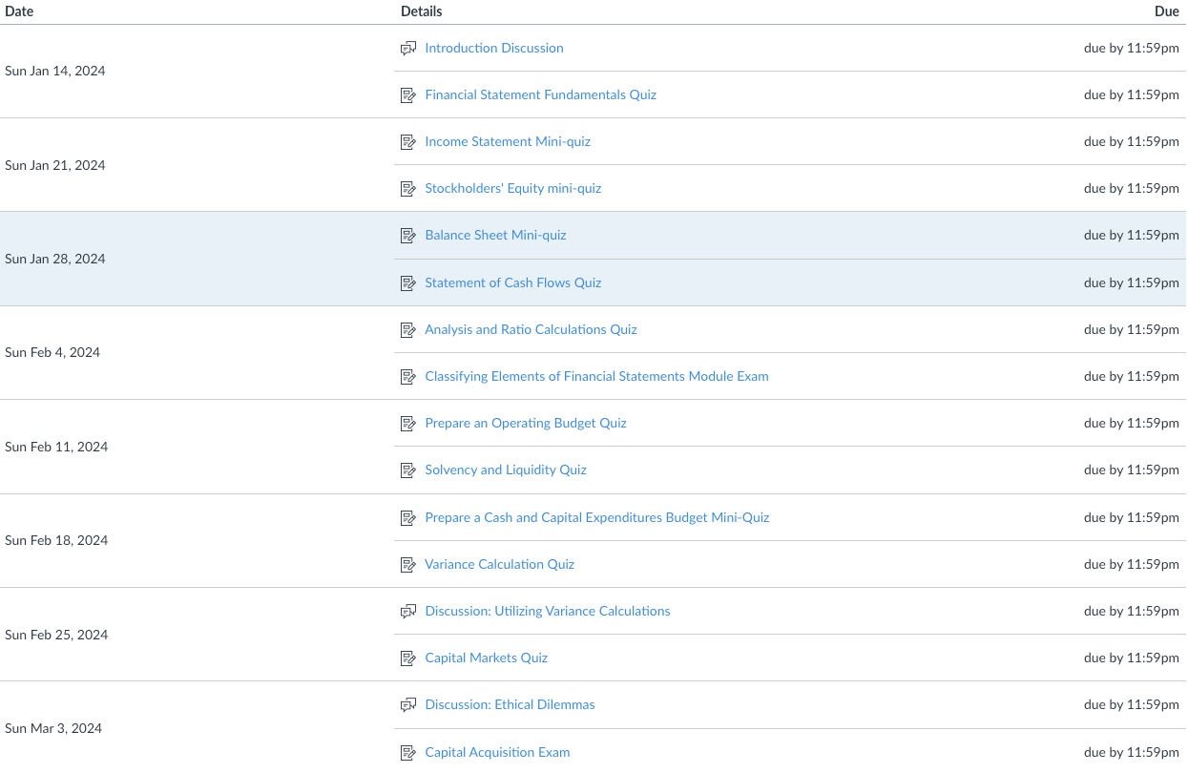

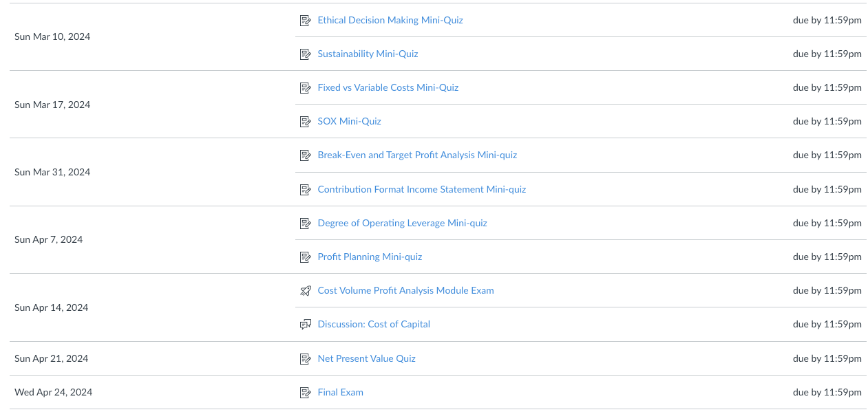
Disclaimer
Changes in this syllabus, schedule, and or course policies may be made during the course per the instructor's discretion to ensure a quality learning experience for all students. Changes will be communicated to students via the Announcements and/or Canvas Inbox tools.

