Part I
1.
Population

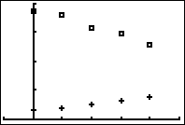
Orlando, Florida
Baltimore, Maryland
1,000,000

500,000

0
Number of Years since 1960
0 20 40

2. Both data sets are linear in form and have a strong association. Baltimore data has a negative direction whereas Orlando has a positive direction.

3. Baltimore: $y=-7,454.85x+952,842.2$
Orlando: $y=2,653.19x+79,751.4$

4. Baltimore: The slope is -7,454.85 and means that the population is decreasing by 7,454.85 every year.
Orlando: The slope is 2,653.19 and means that the population is increasing by 2,653.19 every year.

5. Baltimore: The y-intercept is 952,842.2 and means that the model predicts there were 952,842.2 people in 1960.
Orlando: The y-intercept is 79,751.4 and means that the model predicts there were 79,751.4 people in 1960.

6. Baltimore: The correlation coefficient is $r=-0.989$. Since this is a number close to -1 or 1, the association is very strong. Since it is a negative number, the association has a negative direction.
Orlando: The correlation coefficient is $r=0.990$. Since this is a number close to -1 or 1, the association is very strong. Since it is a positive number, the association has a positive direction.

7.
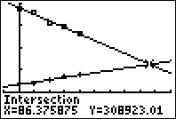

If the population trends continue, then Baltimore and Orlando will both have a population of 308,923.01 near the middle of the year 2046 (86.4 years after 1960).

Part II
1.
Table 1 Graph Population in Thousands
200

100

0
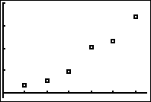
0 20 40 60

Number of Years since 1800

Table 2 Graph Population in Thousands
500

300

0
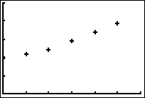
0 20 40 60
Number of Years since 1870
2. Scatterplot from Table 2 seems to be more linear.

3. a.) From scatterplot from Table 2: $y=3.98x+177.64$
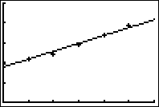
b.) The slope is 3.98 which means that the population is growing by 3.98 thousand or 398,000 people every year.
c.) The correlation coefficient is $r=0.989$. Since it is positive, we see a positive direction (increasing). Since it is close to 1, there is a strong association meaning that we expect our predictions to be fairly accurate between 1870 and 1920 (our collected data values).

4. From scatterplot from Table 1: $y=11.30{(1.05)}^{x}$
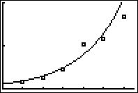

5. Since $b=1.05>1$, the population is growing. The growth factor is 1.05.
Bonus: $1.05=105\%$ Subtracting 100% gives us the percent increase is 5% each year.

6. Using the initial year of 1800 in the exponential table, there are 100 years passed from 1800 to 1900, replace $x=100$. $y=11.30{(1.05)}^{100}=1,485.954$ thousand people or 1,485,964.214 people.

7. Using the initial year of 1870 in the linear table, there are 80 passed from 1870 to 1950, replace $x=80$. $y=3.98\left(80\right)+177.64=496.04$ thousand people of 496,040 people.

8. According to http://en.wikipedia.org/wiki/New_Orleans, the actual population in 1950 was 570,445 people.

9. This is a difference of $570,445-496,040=74,405$ people more people that our model predicted. The “Baby Boom” occurred shortly after WWII beginning in 1946.

10. According to http://en.wikipedia.org/wiki/New_Orleans, the actual population surpassed 600 thousand just before 1960.

11. Using the Linear equation with initial time since 1870, 1960 is 90 years later.
$y=3.98\left(90\right)+177.64=535.84$ thousand people or 535,840 people.
Using the Exponential equation with initial time since 1800, 1960 is 160 years later.
$y=11.30{(1.05)}^{160}=27,756.602$ thousand people or 27,756,602 people.
The Linear equation is a closer predictor. Beginning with 1800, the population in New Orleans grew exponentially until 1870. Then the growth pattern became linear. We should use the linear model to make predictions for time since 1870. Using the linear model we have a residual = actual – predicted value of $600,000 -535,840=64,160$ people difference where our model under-predicted the population. This is to be expected since our data values are between 1870 and 1920. The year 1960 is outside the known data values. We should use caution when making predictions while extrapolating.

