- Playing a PowerPoint Slideshow
  - Double-click on the presentation file that you want to play.
  - Click the Slide Show tab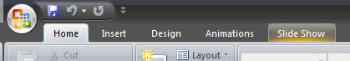located on the top of the screen.
  - In the Slide Show tab, 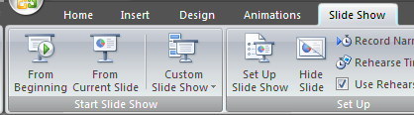click on From Beginning (first icon on the left).
  - Navigate through the slideshow as you did in previous versions (either using arrow keys, or clicking the mouse).

- How to Open a Document
  - Click on the Microsoft Office Button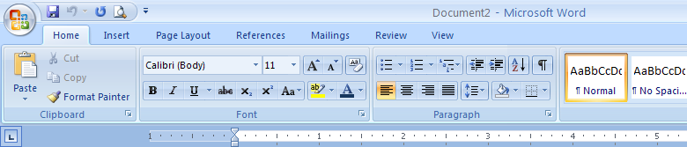 (top left corner)

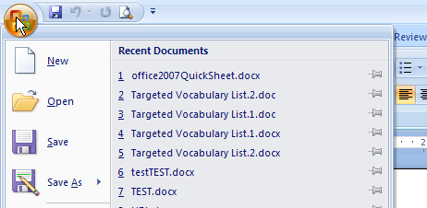
  - Click on “Open.”

  - Navigate to your document as you normally do.

- How to Save a Document
  - Click on the Microsoft Office Button (top left corner)

Option 1: To save as an Office 2007 document, select “Word Document”
Option 2: To save as an Office 2003 document (because you don’t have Office 2007 on your office or home computer), select “Word 97-2003 Document.”
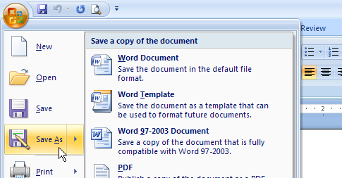
Option 1: Select this to save as an Office 2007 document.

Select this to save as an Office 2007 document

Option 2: Select this to save as an Office 2003 document.

Select this to save as an Office 2007 document

