If Going to a Personal Trainer Was Like Going to Class.
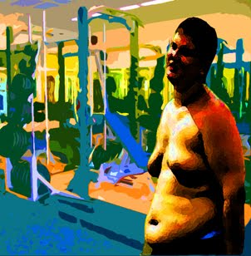Dear Personal Trainer,
My name is George Gymflake and I am in your TR 9 a.m. training session. I know I haven't shown up in a while, but that's because my roommate's boyfriend ran over a ferret that exploded into the engine of her scooter right before he left for a manned mission to Mars, which means she's both distraught and needs a ride everywhere, and she works from 9:02 to 9:51 every Tuesday and Thursday. I would have rescheduled with you, but I thought I would be fine just doing the exercises on my own.
I pay my money, and I remember you saying that if I made appointments with you twice a week, I would see results. I don't understand why I need your specific exercises, when I learned exercises just like them last year at a different gym so I already know them, so I really can do them at home. Plus when I am in the gym and doing the exercises in front of other people, I get anxious and freeze up and can't remember what the exercises are.
My point is, I know I'm quickly approaching the end of my contract, and I haven't lost any weight or gained any muscle. I was wondering if there was anything I could do or say to take a few pounds off before the contract expires. I'd like you to know that I've really enjoyed the sessions that I have come to and I feel like I've learned a lot, but that's just not being reflected in my BMI.
Thank u,
George

