I. Definition: What is the Known-New Contract?

The “known-new contract” (aka. “given-new contract”) is a linguistic concept that describes how a writer maintains cohesion of thought for their readers between sentences and paragraphs. This “cohesion of thought” in writing has to do with the expectations we set up for our readers. Readers understandably demand those expectations to be filled, and a kind of “contract” is made between the writer and the reader which demands that new information be linked to something that is known. The known-new contract assumes that readers read more easily if each sentence starts with (or at least contains) what they have already been introduced to in the text (what they “know”) and proceeds on to what they don't know (what is “new”).

II. Examples: Sentence-to-Sentence

Breach of the Contract

This chapter was written to introduce you to the basic concepts of Alain Badiou’s theory of ethics. A thorough explication will also be presented, situating Badiou’s philosophy in the context of other contemporary approaches. Furthermore, three arguments that suggest new avenues for philosophical inquiry will be outlined, challenging Badiou’s fundamental concepts.

Honoring of the Contract

This chapter was written to introduce the reader to the basic concepts of Alain Badiou’s theory of ethics. Badiou’s concepts will be explicated in the context of other contemporary theories of ethics. In addition to this explication, the reader will also be presented with three critiques of Badiou’s theory of ethics that suggest new horizons for philosophical inquiry.
(new information is in italics)
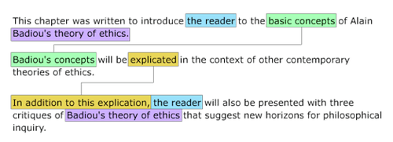

III. Strategies: Four Ways to Honor the Contract

Writers have an obligation to their readers to fulfill expectation that have been created. Therefore, as writers we need to understand how those expectations are created. There are four most commonly used tactics for creating and maintaining cohesion through fulfilling the expectations of the reader between sentences:

- Noun or Pronoun Reference: The second sentence begins with a common noun, noun phrase, or pronoun that refers back to a previous clause in the first sentence.
- Restatement: The second sentence restates some of the information in the first sentence.
- Structural Arrangement: The chain of sentences have a common formal aspect that suggests a listing or rhetorical strategy that links the ideas for the reader back to the main idea.
- Relational Transition: The sentences have words or phrases that define the relationship between them, such as later, on the other hand, similarly, in addition, as a result, also, consequently, in fact, that is, etc.

