MAT1033C Intermediate Algebra Name __________________
Please time yourself, take this quiz and write a self-reflection essay using the space provided below.
Starting time:_________
Ending time:__________
Total time spent:_________minutes
Diagnostic Quiz 1 Quiz 2 Topics Weakness Strength Solution
1 1 1
2 2 2
3 3 3
4 4 4
5 5 5
6 6 6
7 7 7
8 8 8
9 9 9
10 10 10
11
12
13
14
15

_______________________________________ ________________________
Student Signature Date

Quiz 1
- Simplify the expression: −4[-5 -3(−4 + 9)] - 15

 | Solve | Note to yourself

2. Simplify the arithmetic expression: $\frac{1}{15 }+\frac{7}{20}$
 | Solve | Note to yourself

3. Solve the equation: 7( -4 𝑥 + 1) = −2(3𝑥 − 4) +3 𝑥
 | Solve | Note to yourself

4. Evaluate the expression 𝑥² − 3𝑦𝑧 + 3(𝑥 + 𝑦) for 𝑥 = −2, y = - 3, 𝑧 = −1.
 | Solve | Note to yourself

5. Simplify the polynomial: (3𝑥² +2 x - 5)(2𝑥 − 6) − (2𝑥)(5𝑥² +3𝑥 − 4)
 | Solve | Note to yourself

6. A television is on sale for $560. If the sale price is 20% less than the regular price, what was the regular price?
 | Solve | Note to yourself

7. Solve the equation for y: $12x + \frac{5}{6}y - 10 = 4 +2 x$
 | Solve | Note to yourself

8. Factor the trinomial: $2x^{2} - 7x + 6$
 | Solve | Note to yourself

9. Find the x- and y-intercept of the linear equation 5𝑥 − 3𝑦 = −30, and write your answers as ordered pairs.
 | Solve | Note to yourself
10. Graph the line with a slope of $-\frac{2}{5}$ and the y-intercept at (0,4), and write the equation of this line in slope-intercept form.
Note yourself
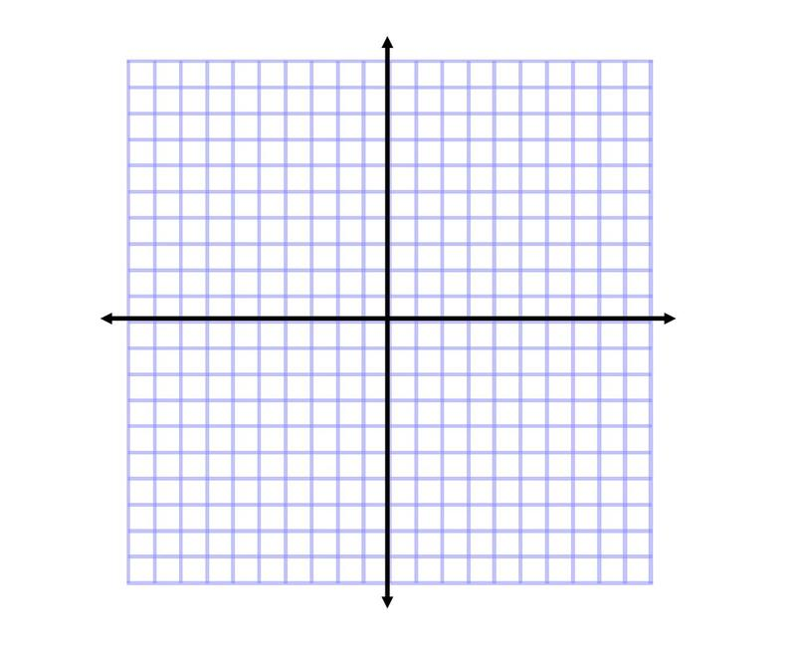

11. Graph 3x - 4y=12
.
12. $y=x^{2}-4$
13. $y= -2$

14. If $4000 is deposited into an account earning simple interest at an annual interest rate of 4.5% for 3 years, how
much interest was earned?

15. If $5000 is deposited into an account earning compound interest at an annual interest rate of 6% for 5 years,
and it is compounded quarterly (thus 4 times per year), how much money is in the account at the end of the 5
years

16. Sophia would like to go on a vacation in 5 years and she expects her total costs to be $8000. If she invests $5700
into a savings account for those 5 years at 4.5% interest, compounding semi-annually, will she be able to go on
vacation?

17. Find the domain and range and determine whether the following relationships are functions
{(2,3) (4,3) (6,3)} Domain:_____________________ Rang:_______________ Function: Yes No
Y=2x-4 Domain:_____________________ Rang:_______________ Function: Yes No
$y=\sqrt{x-3}$ Domain:_____________________ Rang:_______________ Function: Yes No

18. Identify whether each graph is a function

