MAT1033C Intermediate Algebra Name __________________

Self-Diagnostic Test Instructions
This instrument is a self-diagnostic test which will measure your own preparation for MAT 1033. All topics in this diagnostic are pre-requisite knowledge that you will need to have in order to success in MAT 1033.
Directions:
Part 1: Take a look at the Self- Diagnostic test below and rate with the appropriate symbols on how confident you feel that you could successfully complete these problems.
Symbols
I am confident that I could successfully complete the problem with no notes or review.
O I may need to look up notes or review in order to successfully complete the problem.
I am not confident that I could successfully complete this problem on my own, even with notes.
Part 2: Complete the Self- Diagnostic test below outside of class. Show your work on this paper or attach this page as a cover sheet. You may use any textbook, old notes, or online resources for assistance (no tutors). List any resources used for each problem.
Part 3: After completing the Self-Diagnostic test and checking your answers with the answer key provided by your instructor, take a moment to reflect on how you solved these problems and answer the following questions:

a) Did you need to review less than you had thought or more than you had thought?

b) Did you need to review at all?

c) What resources were most helpful to you?

You must accept responsibility for reviewing pre-requisite material needed to learn the subject matter. Your instructor will be able to offer helpful suggestions regarding pre-requisite material.
_______________________________________ ________________________
Student Signature Date

Self-Diagnostic Test
- Simplify the expression: −3[5 + 2(−4 + 9)] + 15

Part I | Part II | Resources Used, if any

2. Simplify the arithmetic expression: $\frac{5}{12 }+\frac{7}{30}$
Part I | Part II | Resources Used, if any

3. Solve the equation: 7(𝑥 + 1) = −2(𝑥 − 4) + 𝑥
Part I | Part II | Resources Used, if any

4. Evaluate the expression 𝑥² − 𝑦𝑧 + 2(𝑥 + 𝑦) for 𝑥 = −2, y = 4, 𝑧 = −1.
Part I | Part II | Resources Used, if any

5. Simplify the polynomial: (𝑥² + 5)(2𝑥 − 6) − (2𝑥)(𝑥² − 3𝑥 − 4)
Part I | Part II | Resources Used, if any

6. A television is on sale for $900. If the sale price is 10% less than the regular price, what was the regular price?
Part I | Part II | Resources Used, if any

7. Solve the equation for y: $2x + \frac{3}{2}y - 1 = 4 + x$
Part I | Part II | Resources Used, if any

8. Factor the trinomial: $2x^{2} - 11x + 5$
Part I | Part II | Resources Used, if any

9. Find the x- and y-intercept of the linear equation 5𝑥 − 3𝑦 = −15, and write your answers as ordered pairs.
Part I | Part II | Resources Used, if any
10. Graph the line with a slope of $-\frac{2}{3}$ and the y-intercept at (0,−2), and write the equation of this line in slope-intercept form.
Part I | Part II | Resources Used, if any
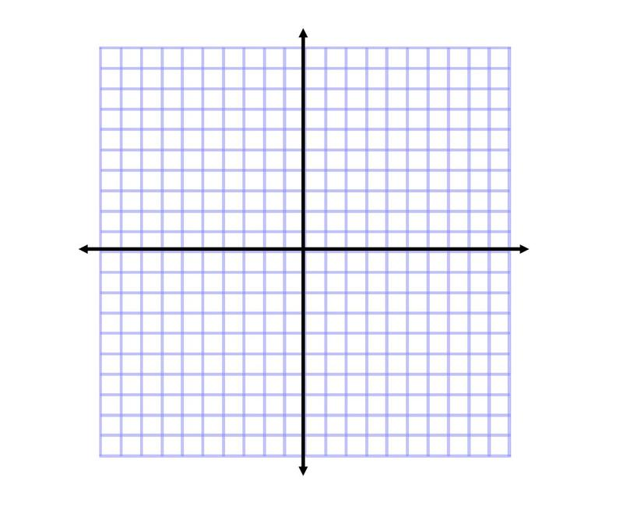
Equation:

